
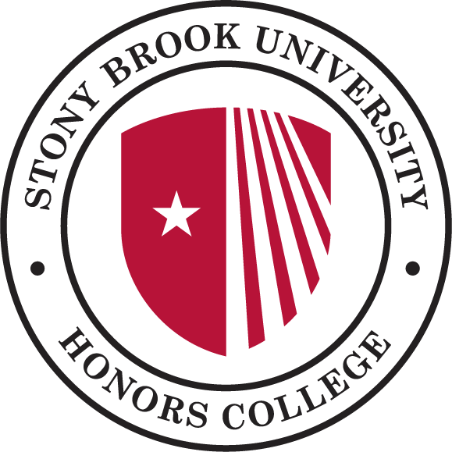
Stony Brook Curriculum (SBC) Honors College Checklist

ARTS → HON 201: The Arts & Society
GLO → HON 401: Global Issues
HUM → HON 105: Modes of Knowledge (partially); HON 106: Modes of Being (partially)
LANG QPS
SBS → HON 105: Modes of Knowledge(partially); HON 106: Modes of Being(partially) SNW
TECH USA WRT
STAS → HON 301: Science, Engineering, Medicine & Society
EXP+ → HON 495 Honors College Senior Project I(partially); HON 496 Honors College Senior Project II(partially)
HFA+ SBS+ STEM+
CER → HON 105: Modes of Knowledge (partially); HON 106: Modes of Being (partially); HON 301: Science, Engineering, Medicine & Society;
DIV → HON 401: Global Issues
ESI → HON 495 Honors College Senior Project I(partially); HON 496 Honors College Senior Project II(partially)
SPK → HON 495 Honors College Senior Project I(partially); HON 496 Honors College Senior Project II(partially)
WRTD → HON 495 Honors College Senior Project I(partially); HON 496 Honors College Senior Project II(partially)

★ SBCs not covered by the Honors College Curriculum → LANG, QPS, SNW, TECH, USA, WRT, HFA+, SBS+, and STEM+
★ HON 105 and 106 do not need to be taken in the first year of they do not fit into a student’s schedule, but must be taken at a later date → Do not need to be taken in sequence
★ HON 201, HON 301, HON 401 → Do not need to be taken in sequence
★ Mini Course - HON 110-120: Honors Topics (1 credit) → Need 3 in order fulfill HC requirements
★ Thesis - HON 495/496: Honors College Senior Project → Taken in sequence

