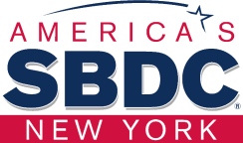

STONY BROOK SMALL BUSINESS DEVELOPMENT CENTER
Presents:

Hispanic Business Strategies Initiative
---------------------------------------------------

M/WBE Certification Bootcamp

Jacqueline R. Franco
NYS Certified Business Advisor Jacqueline.franco@stonybrook.edu 631 632 3252


Cómo prepararse y calificar para tener financiamiento
- Tips para tener buen manejo
financiero del negocio
- Programas de prestamos 7(a) y 504 del SBA
- Opciones de financiamiento para
los dueños de negocios

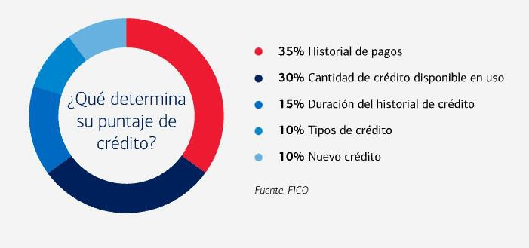
Fuente: Bank of America

Tips para el manejo de sus finanzas
  - Organizar
  - Rutinas diarias
  - Cuentas separadas
  - Plan – Metas – Inversión
  - Hacer seguimiento
  - Conservar buen reporte de crédito



Small Business Administration SBA

Sam Ballena
Outreach Marketing Specialist
- Marketing SBA programs and services through outreach, training, and education to various
organizations and small businesses.
  - Building and maintaining collaborative alliances and partnerships with Resource Partners,
economic development organizations and small business owners
- Working with all stakeholders (Federal, NY State Assembly/Senate, and local leaders) in
pursuing disaster financing resolutions.

PROGRAMAS DE PRESTAMOS 7A & 504 DEL SBA
SBA Loans Explained - YouTube

SBA Loans Explained - YouTube

www.sba.gov

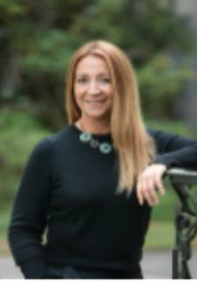
La Fuerza Unida CDC
Giovana Brachi Executive Director www.lafuerzacdc.org

GRACIAS
Jacqueline R. Franco
NYS Certified Business Advisor Specializing in Marketing and Hispanic Market Jacqueline.franco@stonybrook.edu
631 632 3252

