
Leveraging Online Tools to Run Your Business During the Pandemic and Beyond

74% of companies plan to shift at least 5% of their previously on-site workforce to permanently remote positions post-COVID 19.

Managing Remote Workers
The key is to shift your thinking away from time-focused accountability. Rather than fixating on the minutes your team might lose to petting their dogs or making lunch, focus on the bigger picture.

What work do you want them to get done?
How should they deliver it?

Managing Remote Workers

Remote work is all about the deliverables.

Assign work, and set reasonable expectations for delivery timelines.

Remote Tools Stack






Remote Tools Stack

Remote tools offer structure, streamline operations, and hold your company together as it grows.

Cloud-based video conferencing platform that can be used for video conferencing meetings, audio conferencing, webinars, meeting recordings, and live chat.

Zoom has added

2.22 million monthly active users.

What Is Trello?
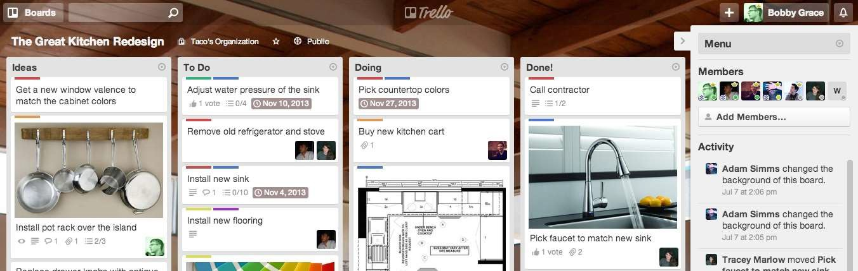
Trello is the easy, free, flexible, and visual way to manage your projects and tasks.

Trello Boards

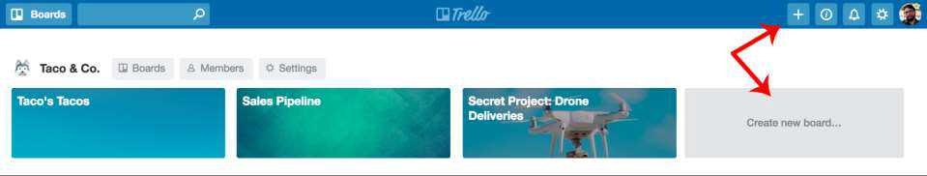
Trello boards contain lists laid out horizontally on the page so you can get a bird’s eye view of your project.

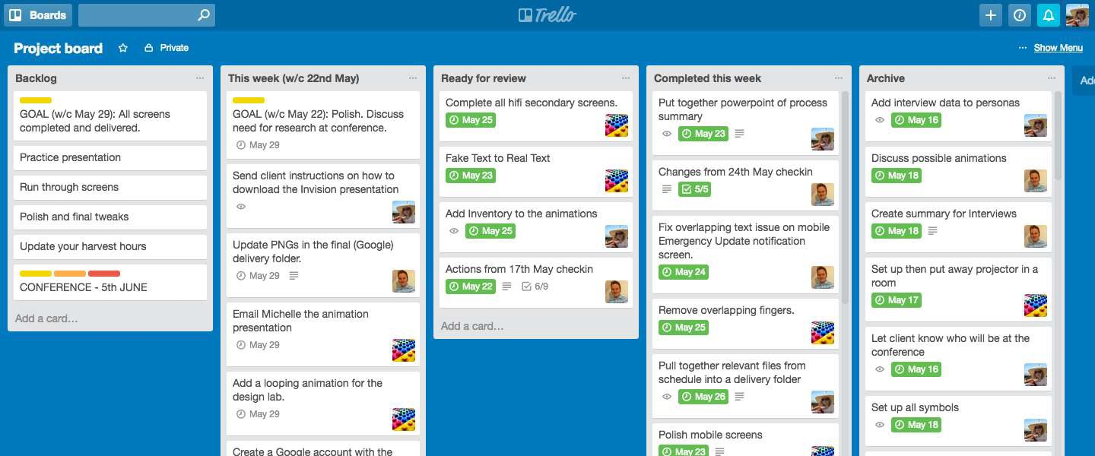
Trello Boards
Boards are where projects get organized, information is shared. Boards are made up of lists and cards.

Trello Lists

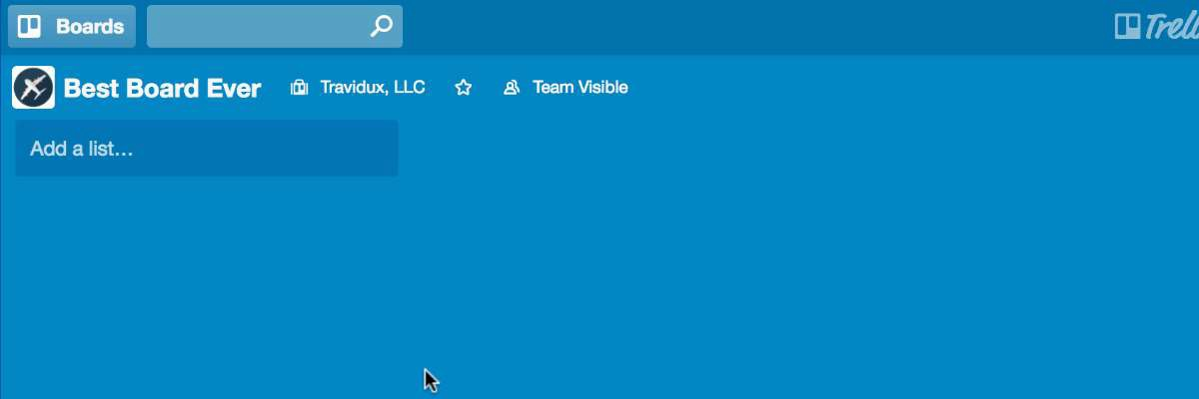
Lists keep cards organized in their various stages of progress.

Trello Cards
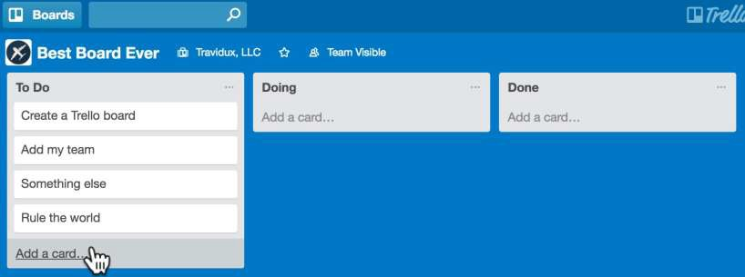
Cards are a fundamental unit of a board.
Cards represent tasks and ideas.

Trello Cards

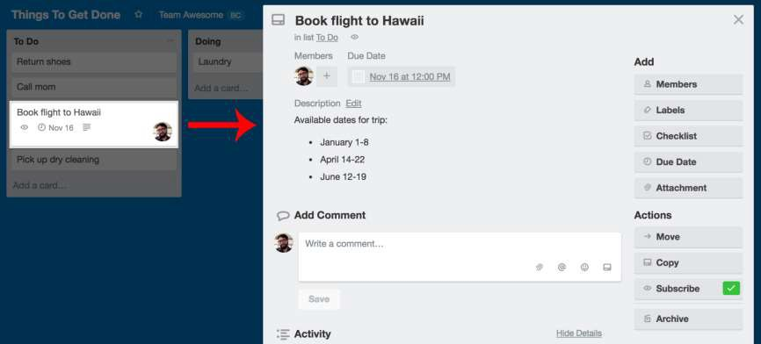

Trello Cards
Cards can be customized to hold a variety of useful information.
Drag and drop cards across lists to show progress.

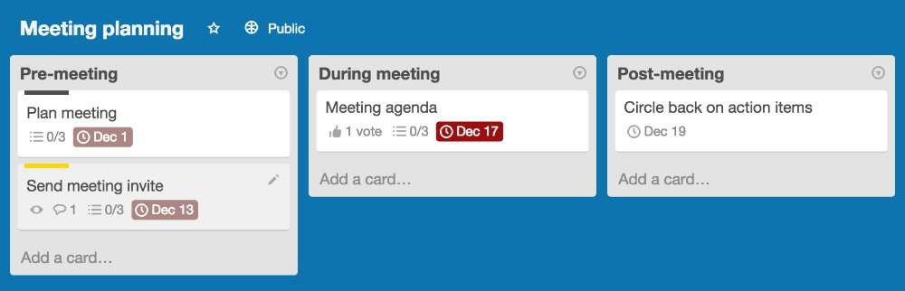

Invite Members
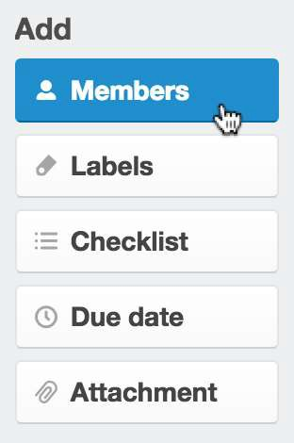
Invite members to your board so that they can be assigned to tasks and collaborate on your board.

The Card Back
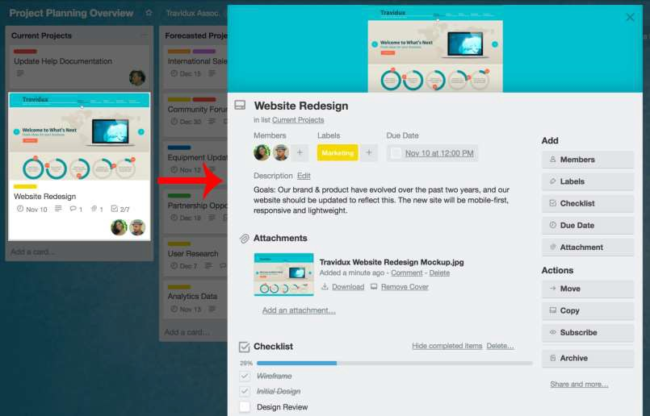

Comments & Activity

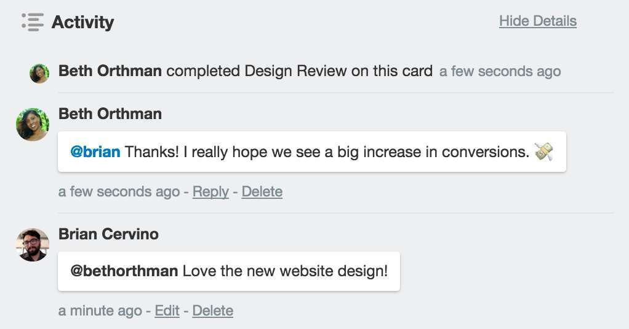

Checklists

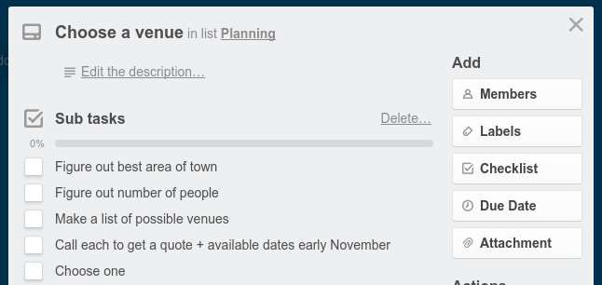

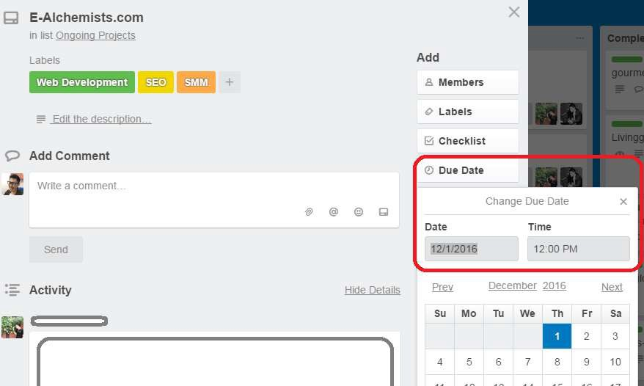
Due Date

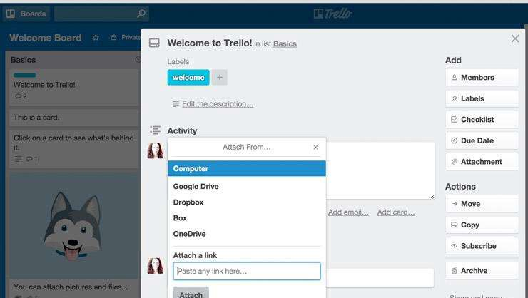
Attachments

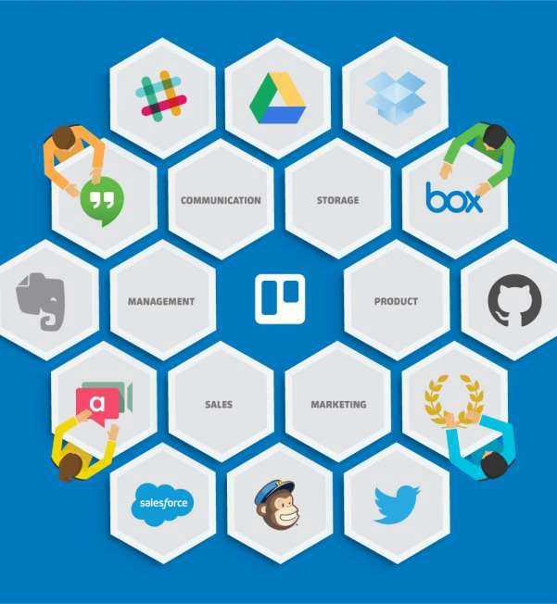

trello.com

What Is Slack?


Slack is an instant messaging and collaboration
system on steroids.

In March, Slack's users went up by
2 million in one week.

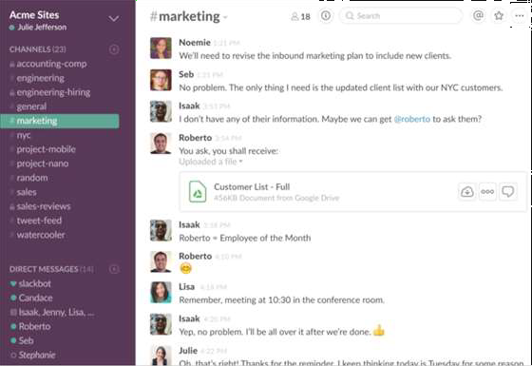

Channels

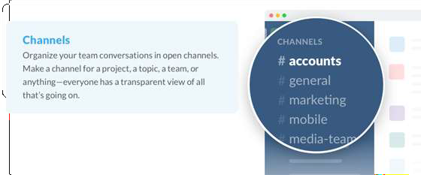

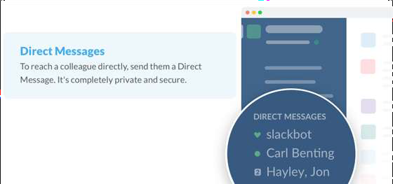
Direct Messages

Share Your Files

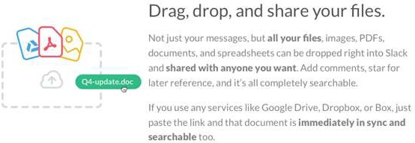

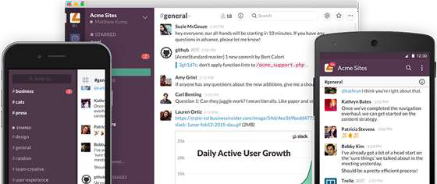
Platforms

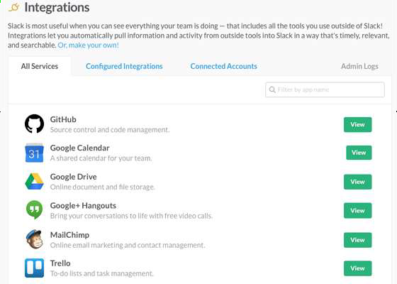

Integration

slack.com

What is Evernote?
A Suite of Software and Services Designed for Notetaking and Archiving.



Evernote Access

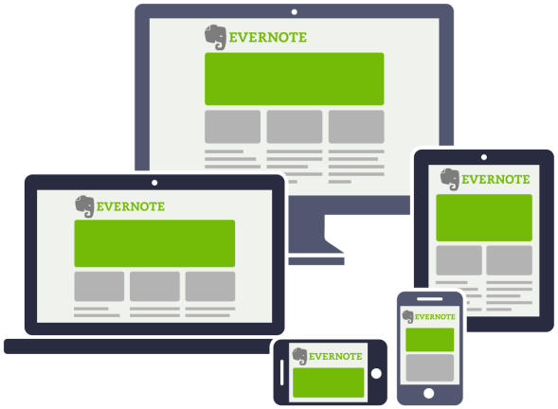
- Install on a PC
- Access via the Website
- Mobile App

Use Evernote For:

STORING IMAGES
Business Cards Accident Info Expense Reports Receipts Whiteboards Screen Capture

SAVING DOCUMENTS
PDFs, Word, Excel
Power Point

IMPORTANT DATA
Passwords Contacts Encrypt Content

Use Evernote For:

RECORDING YOUR THOUGHTS
Record audio from your computer or mobile device

2 Types of Notebooks

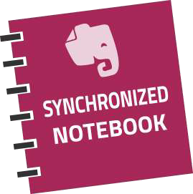


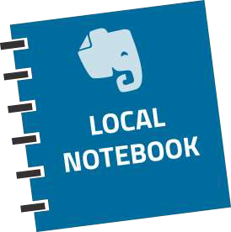
Stored on your desktop and NOT shared with the cloud.
Notebook you are willing to share on the cloud.

Notebooks

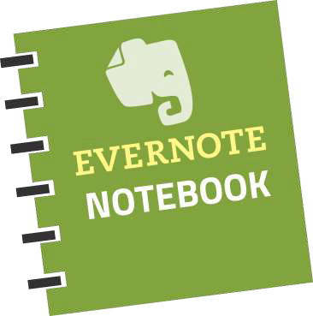
- Up to 250 Notebooks
  - Email Content Directly to a Default Notebook
  - Export (back up) save to desktop

A Note About Notes


- Can Have Attachments
- Sorted into Folders
- Tagged
- Annotated



A Note Can Be…
- Formatted Text
- A Webpage
- Voice Memo
- Photograph
- Handwritten Note

A Note Can Be…

  - Given Comments
  - Searched
  - Shared
  - Exported
  - Edited

Working with Notes
    - Create Text Note
    - Paste PDF into Note
    - Add Screenshots
    - Create Multi-Media Notes
    - Clip Web Content
    - Merge Multiple Notes
    - Create a Note from Email



Sorting Notes
    - Create Tags (Group Notes)
    - Find Text in Notes
    - Advanced Search Options

Rules for Tagging

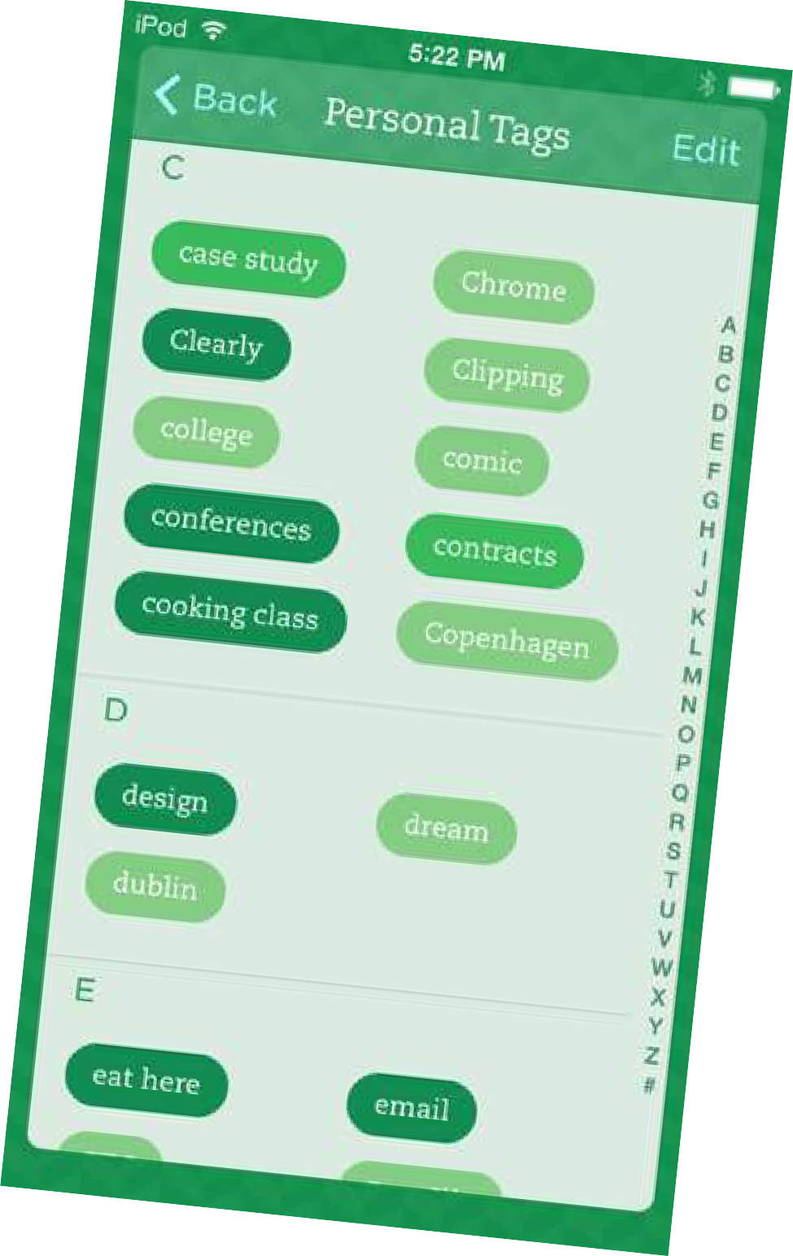
    - Subject of Note
    - Source of Note
    - Specific Projects
    - People & Places

What is Google Drive?

Google Drive is a cloud storage platform to keep all your files in one secure and centralized location.

Remote workers can store and share documents, spreadsheets, and slide presentations.

What is Google Drive?

Google Drive doesn't just store your files; it also allows you to create, share, and manage documents with its
own productivity apps.

Documents



Google Docs
Compose letters, flyers, essays, and other text-based files.
(similar to Microsoft Word documents)

Spreadsheets

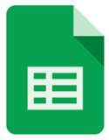

Google Sheets
For storing and organizing information.
(similar to Microsoft Excel workbooks)

Presentations



Google Slides
For creating slideshows.
(similar to Microsoft PowerPoint presentations)

Forms

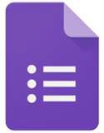

Google Forms
For collecting and organizing
data.



Henry Bramwell

www.vgl.com

631.475.2959

