


HOW TO ACCEPT PAYMENTS ANYWHERE, ANYTIME

CHRISTINE CURZIO
631-374-1237
CHRISTINE@SIMPLYCCP.COM


WHAT EXACTLY IS E-COMMERCE?

- E-Commerce refers to operating an online business, and
- Taking payments for goods and/or services, and
- Using a payment method such as a credit or debit card or an ACH transfer from

your bank account.








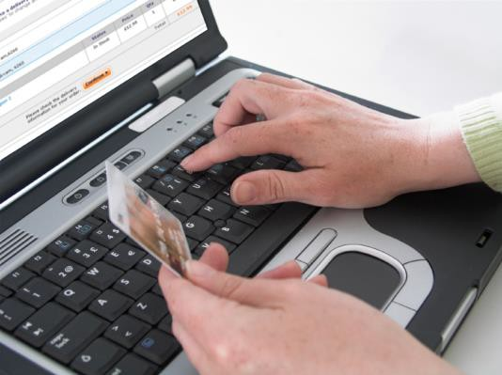




MERCHANT PROCESSING:
3 WAYS TO ACCEPT PAYMENTS
Automated
Online /
e-Commerce
Virtual Terminal / Gateway

Credit Card Terminal











Merchant’s
Website Store
Bank
How a Payment
Gateway works






WHAT IS A VIRTUAL TERMINAL / GATEWAY?
A virtual terminal / gateway is an online method of accepting payments from your
customers.
All you need is an internet connection and
a computer!
Payment Gateway

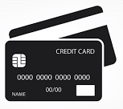

Customer places order
Merchant Receives Funds

If you have more than 5 products, you may want to use Shopify or WooCommerce solutions
Your gateway will offer you invoices and automatically send receipts to your customers

4 EASY STEPS TO ACCEPT CREDIT CARDS ONLINE
Choose
Configure
Set up
Create
Create invoices and receipts
Set up your products on your website
Configure your E-Commerce settings (gateway) including sales tax, if any
Choose a merchant account and gateway and link it to your bank account
Simply Credit Card Processing is one! If you
process less than $5,000 per month, you might want to consider Stripe, Square or PayPal
Gateways like Authorize.net or Network Merchants Inc or Shopify. They offer User Guides and helpful info on their websites.




YOUR WEBSITE: ADDING PAYMENT LINKS

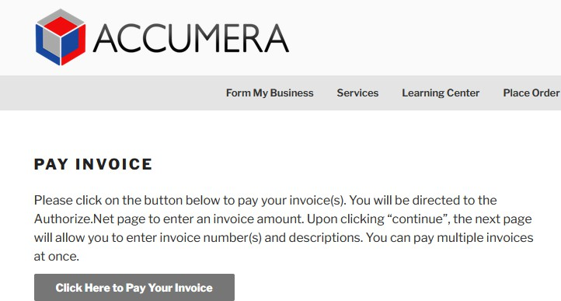
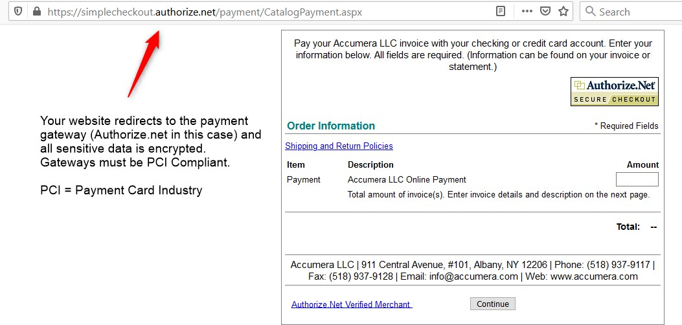
Button on your website that links to your payment page.

YOUR WEBSITE: ADDING PAYMENT LINKS
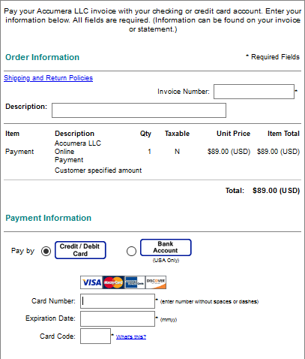
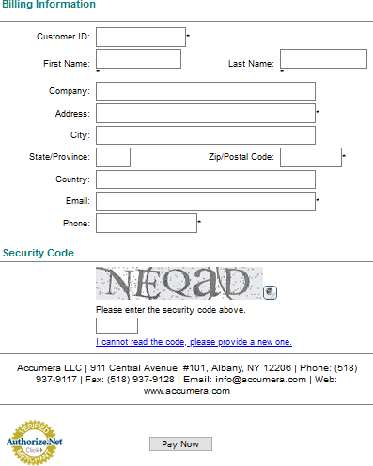

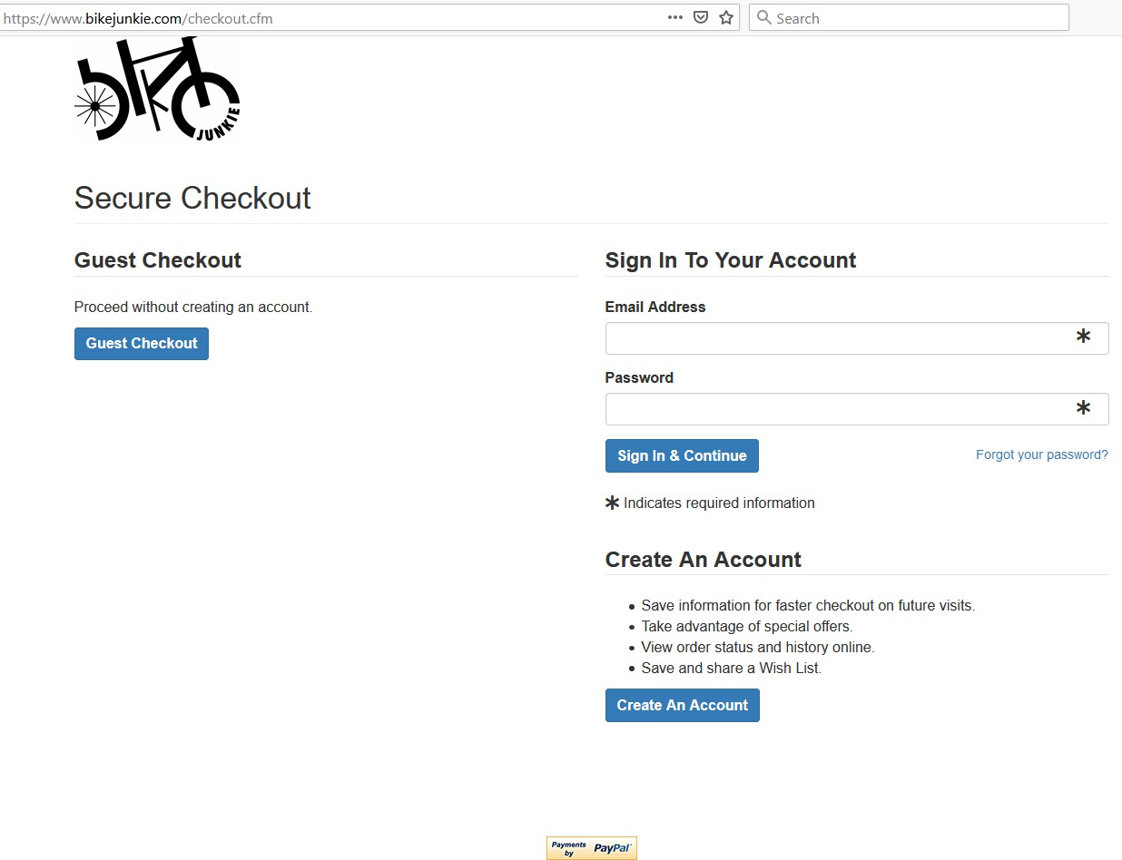
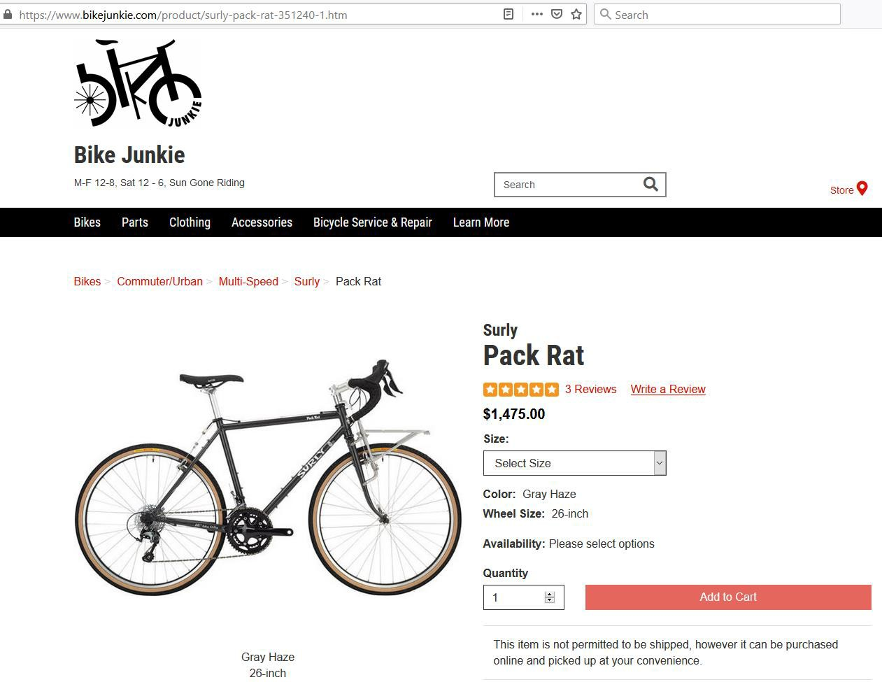

YOUR WEBSITE: ADDING PAYMENT LINKS

Click “Add to Cart” and you are
directed to the Secure Checkout page

POPULAR E-COMMERCE PAYMENT PLATFORMS
www.stripe.com
- Online payment system
- 2.90% + $.30 per transaction for swiped and up to 3.5% + $.15 for keyed transactions
www.square.com
- Offers POS system and great reporting
- 2.60% + $.10 per transaction for swiped and 3.5% +
$.15 for keyed transactions
www.paypal.com
- Popular easy online payment system
- 2.90% + $.30 per transaction for swiped and 3.5% +
$.15 for keyed transactions
- 1.00% transfer fee to your bank acct

HOW TO USE A GATEWAY WITHOUT USING YOUR WEBSITE
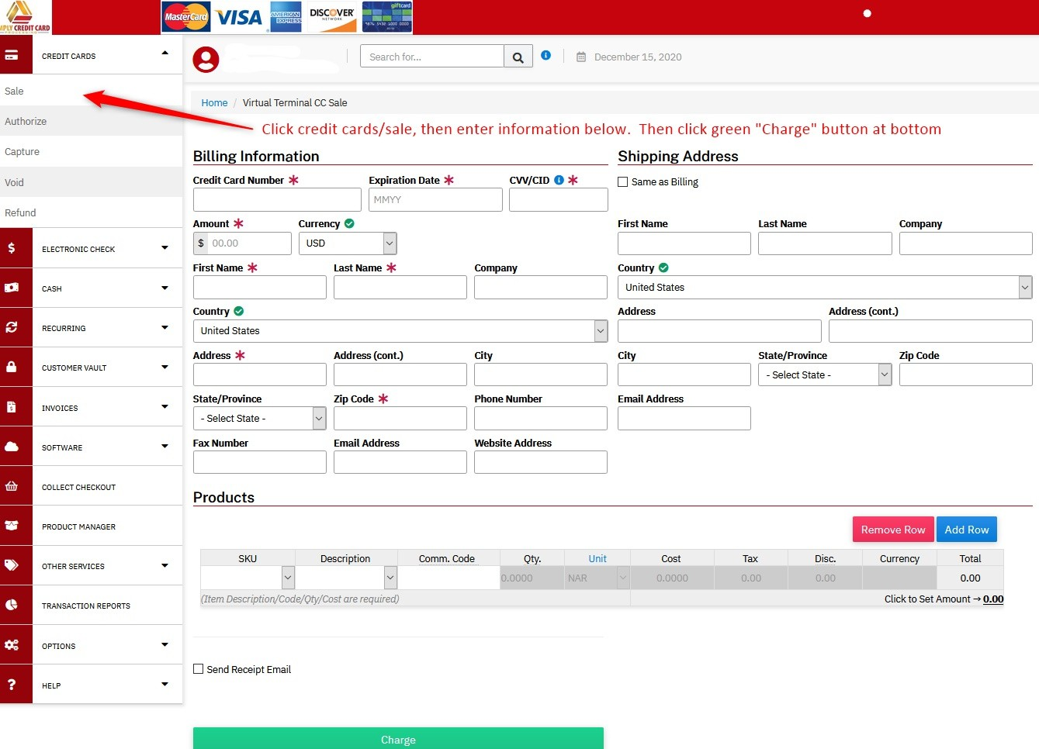

- Login to your gateway with your
User ID and Password.
- Have the cardholders credit card and billing information ready.
- Key in the data and click
“charge”
- Be sure to shred any credit card
data when finished.

If above link does not work, try this: https://simplyccp.transactiongateway.com/merchants/index.php?&tid=cb20731c6 961b3eecca65508a75a1862&tid=cb20731c6961b3eecca65508a75a1862


TEST ACCOUNT
Test Account for you:
Website: https://simplyccp.transactiongateway.com/m erchants
Username: SBDCTest
PW: January28
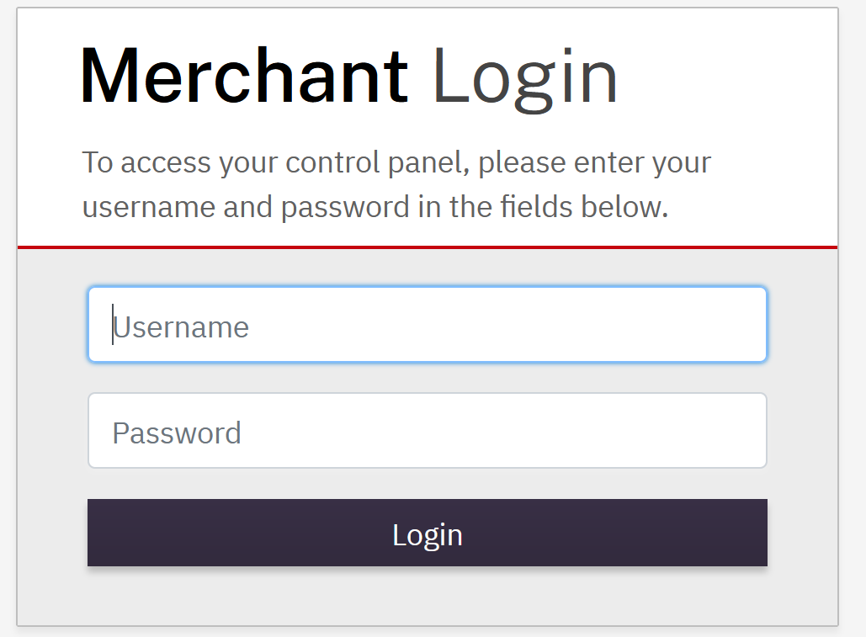

SBDCTest
January28
Test Cards for use in gateway:
Visa: 4111111111111111
MasterCard: 5555555555554444
American Express: 378282246310005

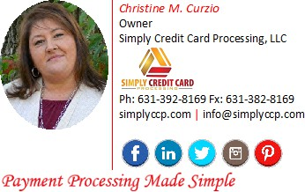
QUESTIONS?


This presentation is available for download on my website
here: http://www.simplyccp.com/about-us/
Scroll to bottom and download the PDF file

