Important: If the first four research milestones listed below are complete, do not use these instructions. Further IRB oversight is not required for your study. Use the Instructions for Closing a Study available here: https://www.stonybrook.edu/commcms/research-compliance/Human-Subjects/submission
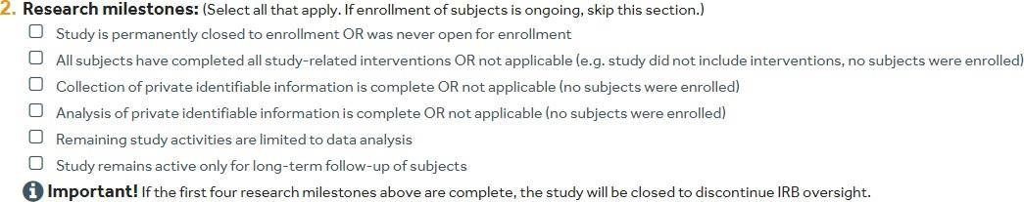
NOTE: Click “save” once you complete each page to ensure that the work on that page is saved.
myResearch does not autosave.

In order to complete a continuing review, click on the study in your inbox that requires continuing review. In the “Next Steps” section of the study on the left-hand side of the screen select “Create Modification/CR”.
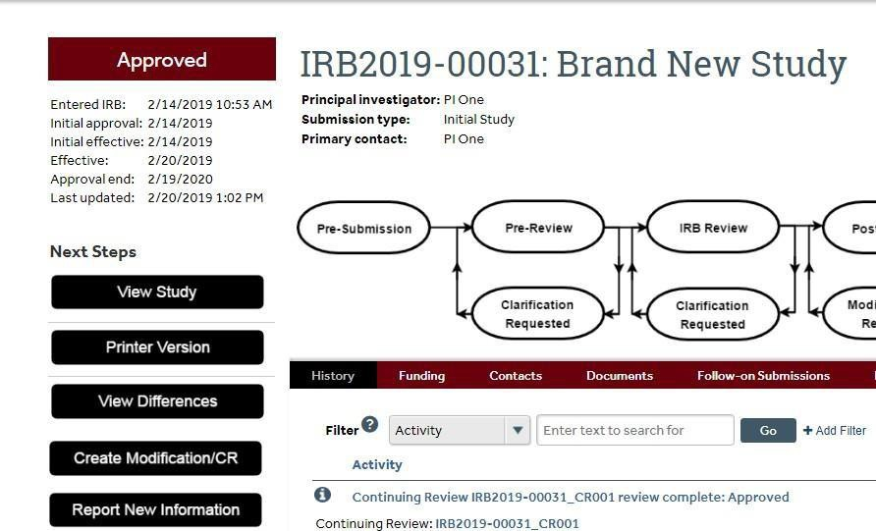

Once you have selected “Create Modification/CR” a new page will open. Select “Modification and Continuing Review” on this page.

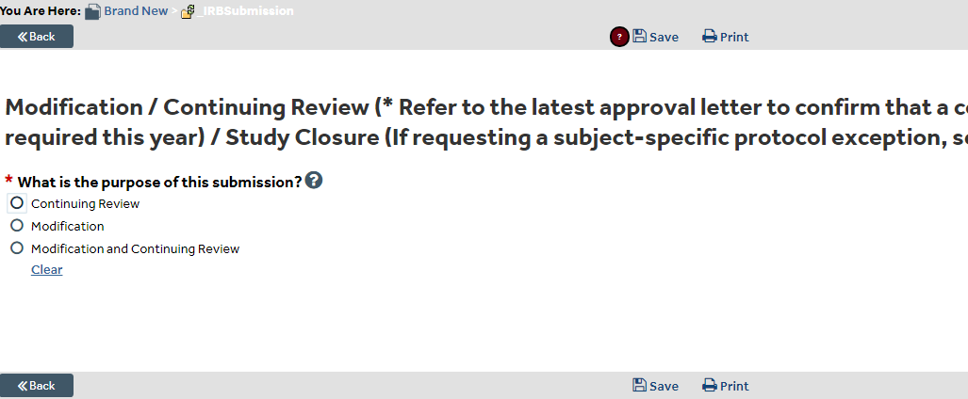
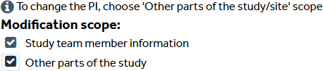
Complete the “Continuing Review” page.
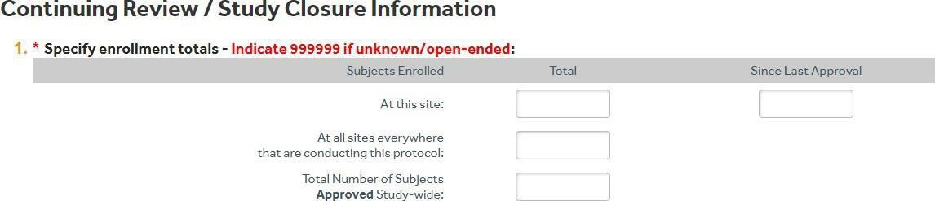

The box on the right-hand side of the screen titled Since Last Approval refers to the number of subjects enrolled in your study since the last IRB approval. If this is not the first renewal, you will enter the number of subjects enrolled since reported at the time of the last renewal.

Total at this site: Number of subjects enrolled by the Stony Brook University investigators.
Total at all sites everywhere that are conducting this protocol: For a single-site study, this is
the same as the total “at this site.” Multi-site studies must include the total enrolled from all sites at the time of renewal.

Total number of subjects approved study-wide: This is the number of subjects that you are approved to enroll in this study, not the number enrolled so far. Refer to the approved protocol for this number.

For question #2, check all boxes that apply since the last approval period.
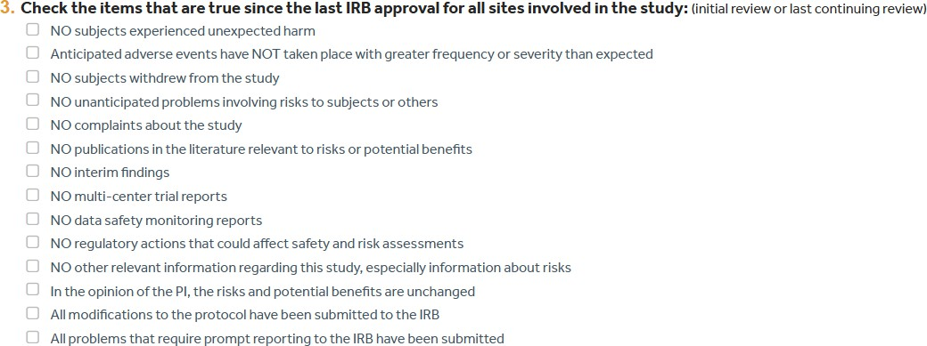

For question #3, check all the boxes that apply since the last approval period.

If there is a box that cannot be checked, upload documentation explaining that item into question #4.

If there was enrollment during the recent approval period, upload the redacted consent form and inclusion/exclusion checklist in question #5. If parental permission and child assent are part of the study, upload one of each. Redact the subject/parent/LAR name, initials, and signature for each form on all pages if applicable.

If there are modifications to the study (i.e., change in procedures, change in study personnel, etc.) summarize each modification and provide a rationale for each modification in the “Summarize the modifications” box.
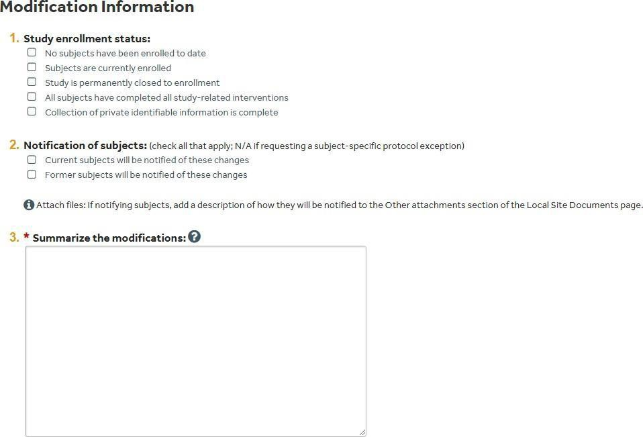
Ensure that all modifications are made in the rest of the myResearch application by updating and replacing revised documents, uploading new study documents, and reviewing the study team list.
- Provide the updated version of the protocol (if applicable) using track changes. Make sure to update the version and date on the first page of the protocol.
- Confirm that the study team member list is current and that all CITI training is up to date.
- Provide the current consent/parental permission/assent forms with track changes (if changes are being made to the forms) as well as a clean version for stamping purposes.
- Provide the current recruitment materials.
When the application is ready to submit, select . This will show a list of required sections that need to be completed.

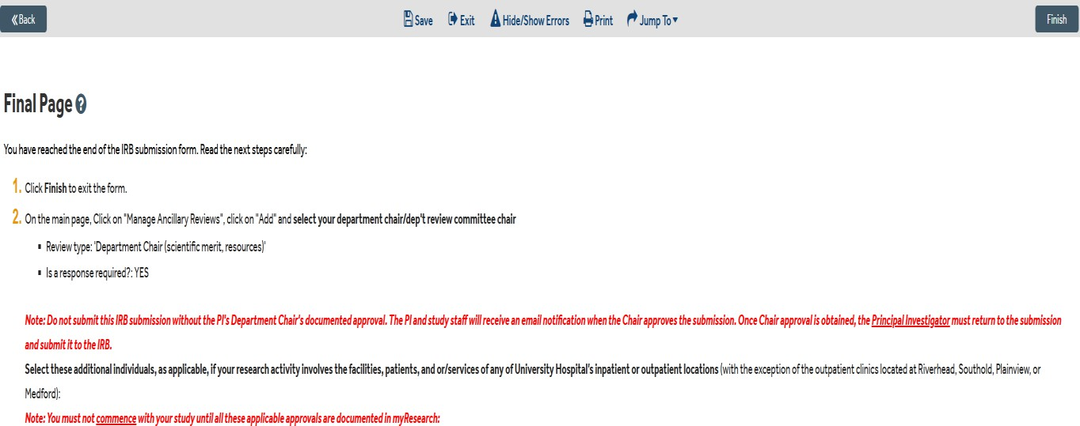

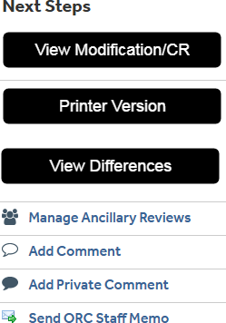
On the “Final Page”, click “Save” and then “Finish” to exit the form. On the left-hand side of the main page click “Manage Ancillary Reviews”. Click “Add” and select the Department Chair for approval.
The Department Chair must submit their review before the study PI can click “submit”. Once the PI clicks “submit” the study will move from “Pre-Submission” to “Pre-Review”.
