To log onto CITI, go to: htps://www.ci�program.org/?pageID=668
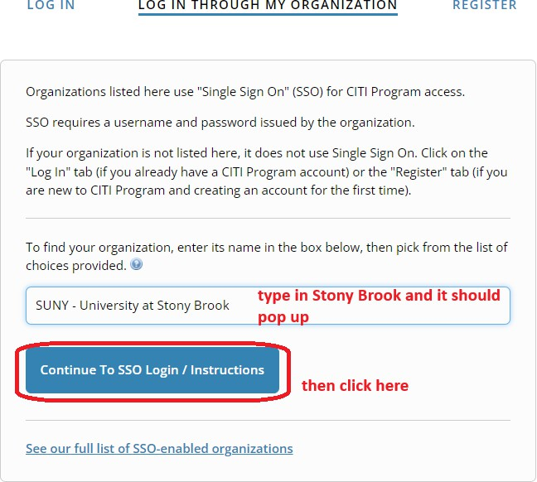

To add an appropriate course:

To add the COI course:

You must then selected either the course that sa�sﬁes Public Health Service requirements or does not. If there is a chance that you may apply for or join a study team that may get Public Health Service funding (such as NIH funding), then selected “yes”.

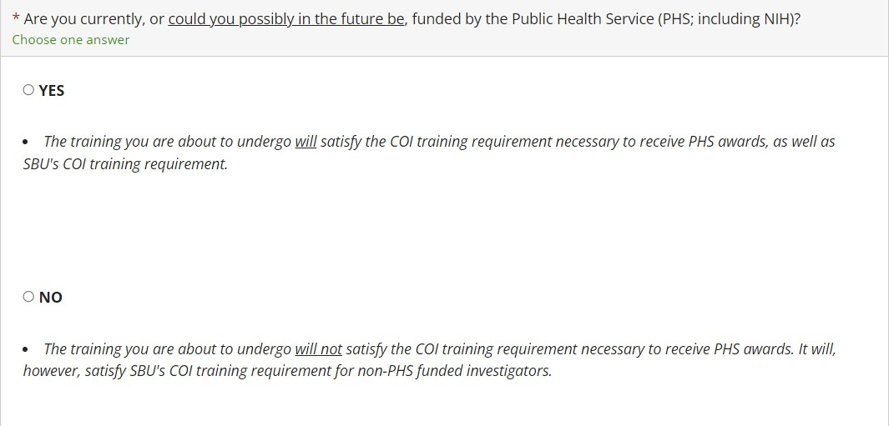
The course should then be added to your Courses Ready to Begin list on CITI.

