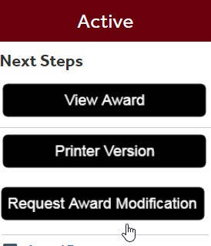
Once you access your Award (AWD#) in myResearch, look for the Request Award Modification action on the left side of your screen. You will be directed to a new page that will request details of your intended action.

All fields marked with an asterisk (*) are mandatory.
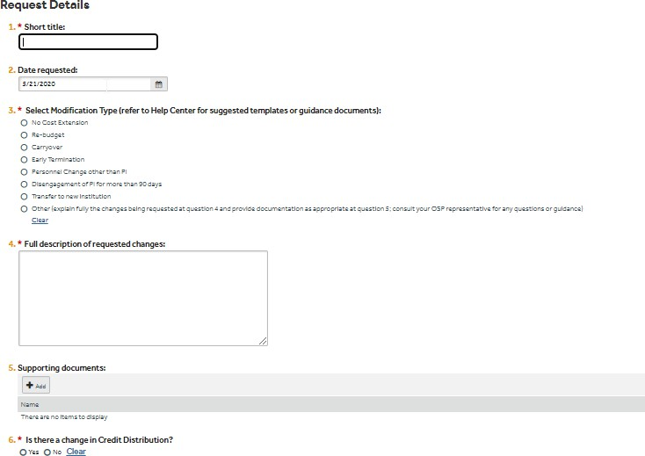
********************************************************8

For No-Cost Extensions

  - Choose the appropriate justification.
  - If your effort changes during the no cost extension period, include the new effort.
  - If any personnel is removed during the no cost extension period, provide their names.
  - If you have a subaward that will be extended during the no cost extension period, submit a purchase requisition to your OSP Specialist.

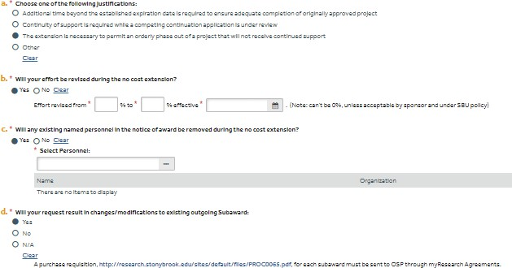

For Re-Budgeting:
A change in budget may require sponsor approval. All requests that require sponsor approval, as all as all SOM re-budget requests, must be submitted through myResearch. Work with your OSP Specialist and your OGM Analyst on re-budgeting requests and questions.
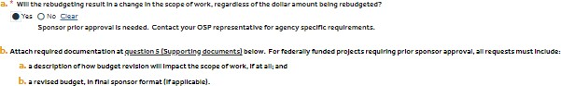

For Carryover:
Follow the instructions for the documentation needed by OSP in order to process your request.
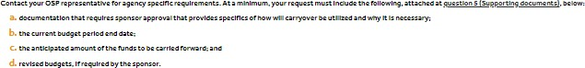

For Early Termination
Provide the requested termination date and a justification.

For Personnel Change other than the PI
If new personnel is added, add their names and follow the instructions on the supporting documentation needed by OSP to process your request.
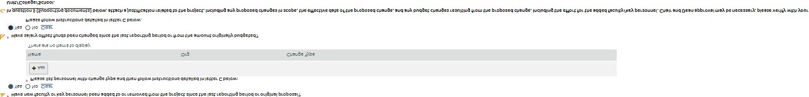

For Disengagement of PI for more than 90 days

For Transfer to new institution
Contact your OSP representative for agency specific requirements. At a minimum, your request must include the following, attached at question 5 (Supporting documents), below:
  - contact information of the office equivalent to OSP at the new institution;
  - Attach letter signed by Chair and Dean indicating which awards are approved for transfer to the new institution, status of existing equipment if applicable, effective date of the transfer, plans for awards remaining at SBU, if applicable, and
  - sponsor approval if already obtained from the sponsor [non-federal projects only].

For Other
Explain fully the changes being requested and provide documentation as appropriate; consult your OSP representative for any questions or guidance.
*************************************************************

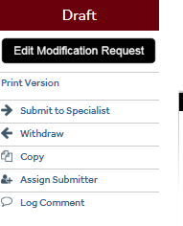
Once you complete the SmartForm, click Finish. You will be prompted to a new page that will give you the option to withdraw, copy, assign a submitter, or submit to your OSP Specialist.

Once you click Submit to Specialist, you will be redirected to a new page that will allow you to make comments and submit supporting document. You attest that any changes related to adjustments in effort, credit distribution and/or addition/removal of faculty or key personnel are in line with your Unit/School/College and RF policies, and that you have received the appropriate approvals from your Unit/School/College. NOTE: SOM requests will not be processed without SOM’s OSA review and approval.
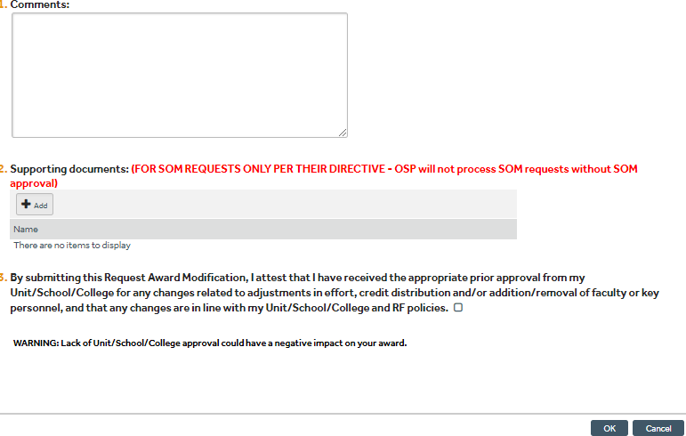

Click OK. Your action will change status from Draft to Review

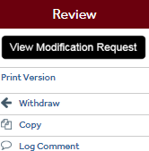
During Review, you can withdraw, copy your request or log comments.

