Fall 2025 ESE 124: Programming Fundamentals
This course covers basic and advanced C programming concepts, with lectures delving into language constructs and practical applications. Additionally, it introduces key
electrical and computer engineering concepts such as bitwise operations, text file scanning, and stack-based computation. Scheduled lab sessions focus on creating, debugging, and validating C programs related to class material, and a final project requires students to utilize the learned concepts in a comprehensive program

Course Designation: Required Course
Credit Hours: 4
Text book: None
Attendance: Mon Aug 25th to Wed Dec.3rd
Lectures: Hariman Hall 111WEST CAMPUS on Mon./Wed. 11 a.m. – 12:20 p.m. Labs 1: Light Engineering Room #281 on Tue 8 a.m. – 10:50 a.m.
Labs 2: Light Engineering Room #281 on Mon 8 a.m. – 10:50 a.m.

Instructor: Jenny Chen, jenny.chen.4@stonybrook.edu
Office Hours: Mon/Wed 1:30 p.m. – 3:30 p.m. Or by appointment.

Goals: Understand C fundamentals (syntax, data types, functions, pointers, bitwise operations, text file scanning, stack-based computation, table-based finite state machine implementation etc.), write clear programs, solve problems, and prepare for advanced computer science and engineering.
Grading:
Lab Activity 20%; Pop Quizzes 15%; Midterm – 25%; Final – 25%; Final Project - 15%
Late Submissions: Grades will be deducted of one-quarter grade for each day a submission is overdue. No make up midterm & Final.
Exams: there are 1 midterm (Wed 10/8 at 11 – 12:20 PM) and 1 final exam (Mon 12/15). No make up exam. Final Project due Tue 12/16 at 11:59 PM.

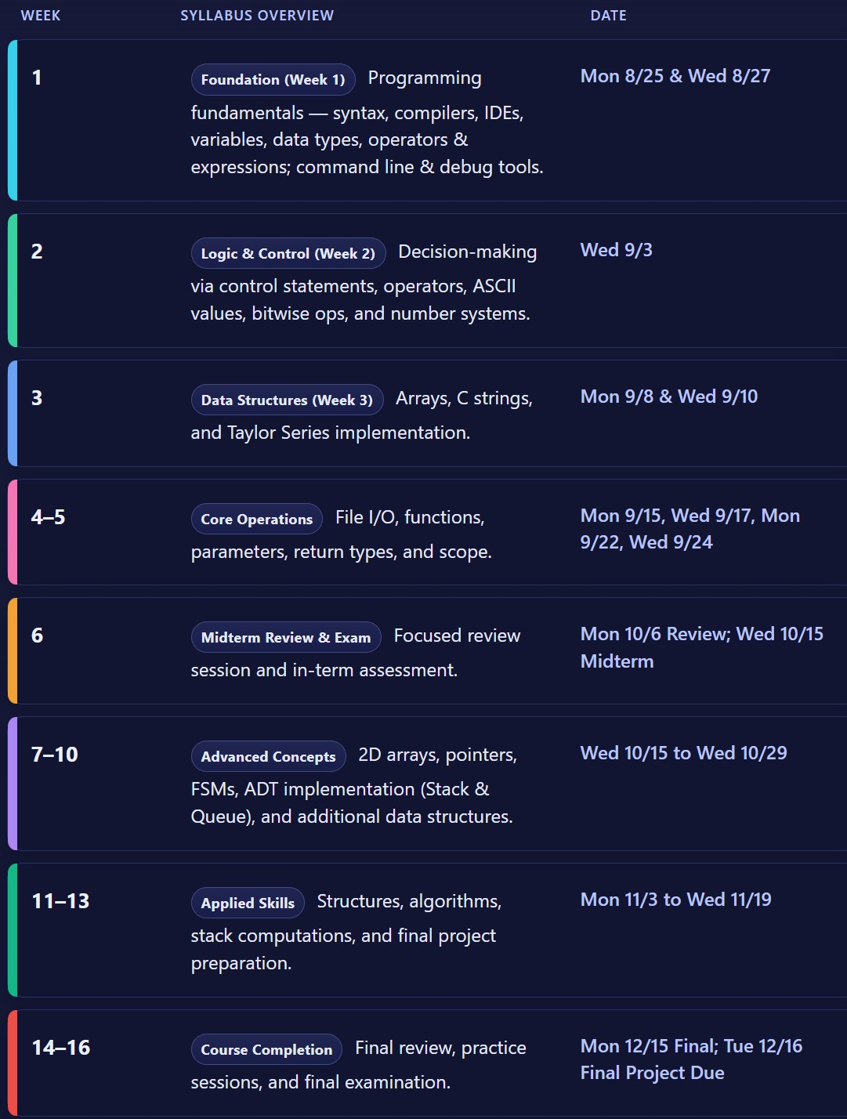

How to succeed in this course?
- Modules start on Monday and end before the next ones begin. All lab activities and assignments are mandatory unless stated otherwise.
- Study for at least 2 hours daily, use resources on the BS reference tab/PPT, and think about answers before checking solutions.
- Complete one lab activity each week with submissions to GitHub (link is in the BS Assignment tab) due by Sunday 11:59 pm. Late submissions lose one-quarter grade per day.
- Student Accessibility Support Center Statement
- If you have a physical, psychological, medical, or learning disability that may impact your course work, please contact the Student Accessibility Support Center, 128 ECC Building, (631) 632-6748, or via e-mail at: sasc@stonybrook.edu. They will determine with you what accommodations are necessary and appropriate. All information and documentation is confidential.

- Academic Integrity Statement
- Each student must pursue his or her academic goals honestly and be personally accountable for all submitted work. Representing another person's work as your own is always wrong. Faculty is required to report any suspected instances of academic dishonesty to the Academic Judiciary. Faculty in the Health Sciences Center (School of Health Technology & Management, Nursing, Social Welfare, Dental Medicine) and School of Medicine are required to follow their school-specific procedures. For more comprehensive information on academic integrity, including categories of academic dishonesty please refer to the academic judiciary website at http://www.stonybrook.edu/commcms/academic_integrity/index.html

- Critical Incident Management
- Stony Brook University expects students to respect the rights, privileges, and property of other people. Faculty are required to report to the Office of University Community Standards any disruptive behavior that interrupts their ability to teach, compromises the safety of the learning environment, or inhibits students' ability to learn. Faculty in the HSC Schools and the School of Medicine are required to follow their school-specific procedures. Further information about most academic matters can be found in the Undergraduate Bulletin, the Undergraduate Class Schedule, and the Faculty-Employee Handbook.

- Document Prepared by:
- Date: 8/21/2025

