ESE 271: Electrical circuit analysis
Fall 2024

The course is designed to provide the necessary theoretical background for electronic lecture and lab courses like ESE 211, 218, 311, 314, 324, 372, etc. The course covers the following topics: passive circuit elements: resistors, capacitors, inductors. Elements of circuit topology. Kirchhoff’s and Ohm’s law. Nodal and mesh analysis. Equivalent circuits. Steady-state AC circuits. Phasors. Transient analysis. Fourier and Laplace transforms. Fundamentals of AC power, coupled inductors (transformers). Two-port networks.

Course Designation: Required Course

Text Books: Main: Charles K. Alexander and Matthew N.O. Sadiku “Fundamentals of Electric Circuits”, McGraw Hill, ISBN 978-0-007-352955-4

Additional/alternative:
R.E. Thomas, R.J. Rosa, G.J. Toussaint “The analysis and design of linear circuits”, 7 th Edition, Willey, ISBN 978-1-119-06558-47
F. T. Ullaby, M. M. Maharbiz, C. M. Furse “Circuits”, 3rd edition, National Technology and Science Press, ISBN 978-1-934891-19-3

Prerequisites: MAT 127 or 132 or 142 or 171 or AMS 161; PHY 127 or 132/134 or 142.
Credit Hours: 3

Instructor: S.Suchalkin, sergey.suchalkin@stonybrook.edu

Goals: The goal of the course is to develop skills of theoretical circuit analysis and circuit design.

Lectures are given on Mondays and Wednesdays 6:30p.m. – 7:50 p.m. in room 250, Frey Hall

Office hours Tuesdays and Thursdays 11:00 a.m. – 1:00 p.m., room 253, Light Engineering Building

Exams: there are 2 midterm and 1 noncumulative final exam.

Grading: Homework 10%; Midterm 1 – 25%; Midterm 2 – 30%; Final – 35%.

Topics Covered:
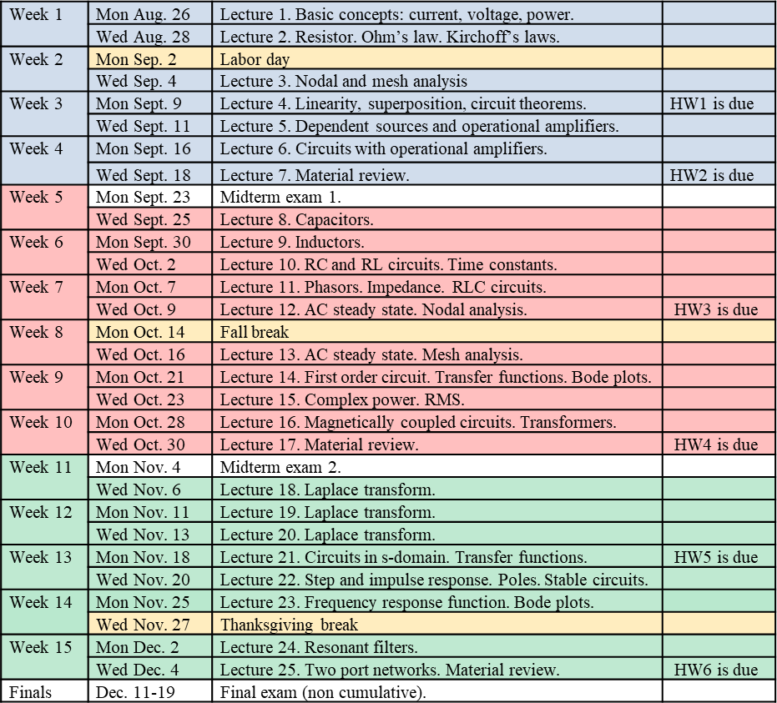

Student Accessibility Support Center Statement
If you have a physical, psychological, medical, or learning disability that may impact your course work, please contact the Student Accessibility Support Center, 128 ECC Building, (631) 632-6748, or via e-mail at: sasc@stonybrook.edu. They will determine with you what accommodations are necessary and appropriate. All information and documentation is confidential.
Academic Integrity Statement

Each student must pursue his or her academic goals honestly and be personally accountable for all submitted work. Representing another person's work as your own is always wrong. Faculty is required to report any suspected instances of academic dishonesty to the Academic Judiciary. Faculty in the Health Sciences Center (School of Health Technology & Management, Nursing, Social Welfare, Dental Medicine) and School of Medicine are required to follow their school-specific procedures. For more comprehensive information on academic integrity, including categories of academic dishonesty please refer to the academic judiciary website at http://www.stonybrook.edu/commcms/academic_integrity/index.html

Critical Incident Management
Stony Brook University expects students to respect the rights, privileges, and property of other people. Faculty are required to report to the Office of University Community Standards any disruptive behavior that interrupts their ability to teach, compromises the safety of the learning environment, or inhibits students' ability to learn. Faculty in the HSC Schools and the School of Medicine are required to follow their school-specific procedures. Further information about most academic matters can be found in the Undergraduate Bulletin, the Undergraduate Class Schedule, and the Faculty-Employee Handbook.

