ESE 271: Electrical circuit analysis
Fall 2020

The course is designed to provide the necessary theoretical background for electronic lecture and lab courses like ESE 211, 218, 311, 314, 324, 372, etc. The course covers the following topics: passive circuit elements: resistors, capacitors, inductors. Elements of circuit topology. Kirchhoff’s and Ohm’s law. Nodal and mesh analysis. Equivalent circuits. Steady-state AC circuits. Phasors. Transient analysis. Fourier and Laplace transforms. Fundamentals of AC power, coupled inductors (transformers). Two-port networks.

Course Designation: Required Course

Text Books: Main: Charles K. Alexander and Matthew N.O. Sadiku “Fundamentals of Electric Circuits”, McGraw Hill, ISBN 978-0-007-352955-4

Additional: R.E. Thomas, R.J. Rosa, G.J. Toussaint “The analysis and design of linear circuits”, 7 th Edition, Willey, ISBN 978-1-119-06558-47

Prerequisites: MAT 127 or 132 or 142 or 171 or AMS 161; PHY 127 or 132/134 or 142.

Credit Hours: 3

Instructor: S.Suchalkin, sergey.suchalkin@stonybrook.edu

Goals: The goal of the course is to develop skills of theoretical circuit analysis and circuit design.

Lectures are given remotely (Zoom) on Mondays and Wednesdays 8:30 a.m. – 9:50 a.m.

Office hours are offered remotely (Zoom) on Thursdays 11:00 a.m. – 1:00 p.m.

Exams: there are 2 midterm and 1 noncumulative final exams.

Grading: Homework 10%; Midterm 1 – 25%; Midterm 3 – 30%; Final – 35%.

Topics Covered:
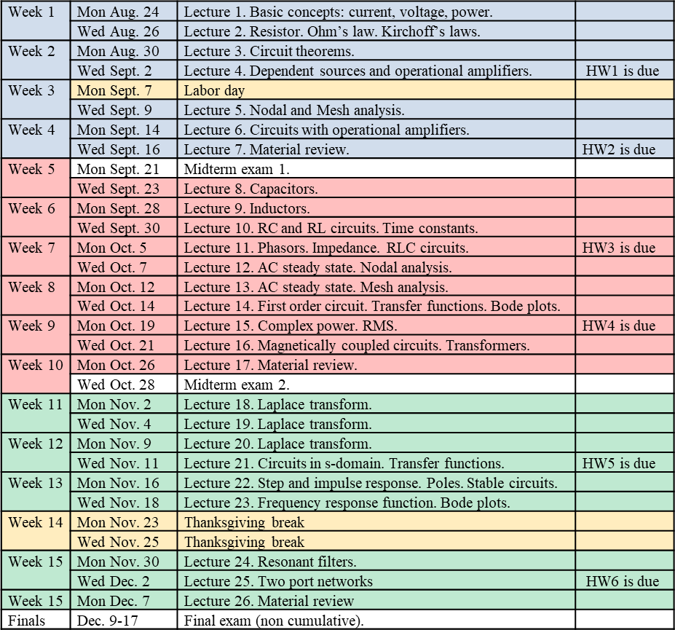

If you have a physical, psychological, medical or learning disability that may impact your course work, please contact the Student Accessibility Support Center, ECC (Educational Communications Center) Building, Room 128, (631)632-6748.

