ESE 271: Electrical circuit analysis
Fall 2017
2016-2017 Catalog Description:
The course is designed to provide the necessary theoretical background for electronic lecture and lab courses like ESE 211, 218, 311, 314, 324, 372, etc. The course covers the following topics: passive circuit elements: resistors, capacitors, inductors. Elements of circuit topology. Kirchhoff’s and Ohm’s law. Nodal and mesh analysis. Equivalent circuits. Steady-state AC circuits. Phasors. Transient analysis. Fourier and Laplace transforms. Fundamentals of AC power, coupled inductors (transformers). Two-port networks.

Course Designation: Required Course

Text Books: Main: Charles K. Alexander and Matthew N.O. Sadiku “Fundamentals of Electric Circuits”, McGraw Hill, ISBN 978-0-007-352955-4

Additional: R.E. Thomas, R.J. Rosa, G.J. Toussaint “The analysis and design of linear circuits”, 7 th Edition, Willey, ISBN 978-1-119-06558-47

Prerequisites: MAT 127 or 132 or 142 or 171 or AMS 161; PHY 127 or 132/134 or 142.

Credit Hours: 4

Instructor: S.Suchalkin

Goals: The goal of the course is to develop skills of theoretical circuit analysis and circuit design.

Course Learning Outcomes: Upon completion of the course, students will have:
- understanding of the operation principles of the electronic circuits
- experience in analysis of DC, AC and transient response of electronic circuit.
- some knowledge of contemporary issues;
- an awareness of the importance of lifelong learning
- practiced communication skills

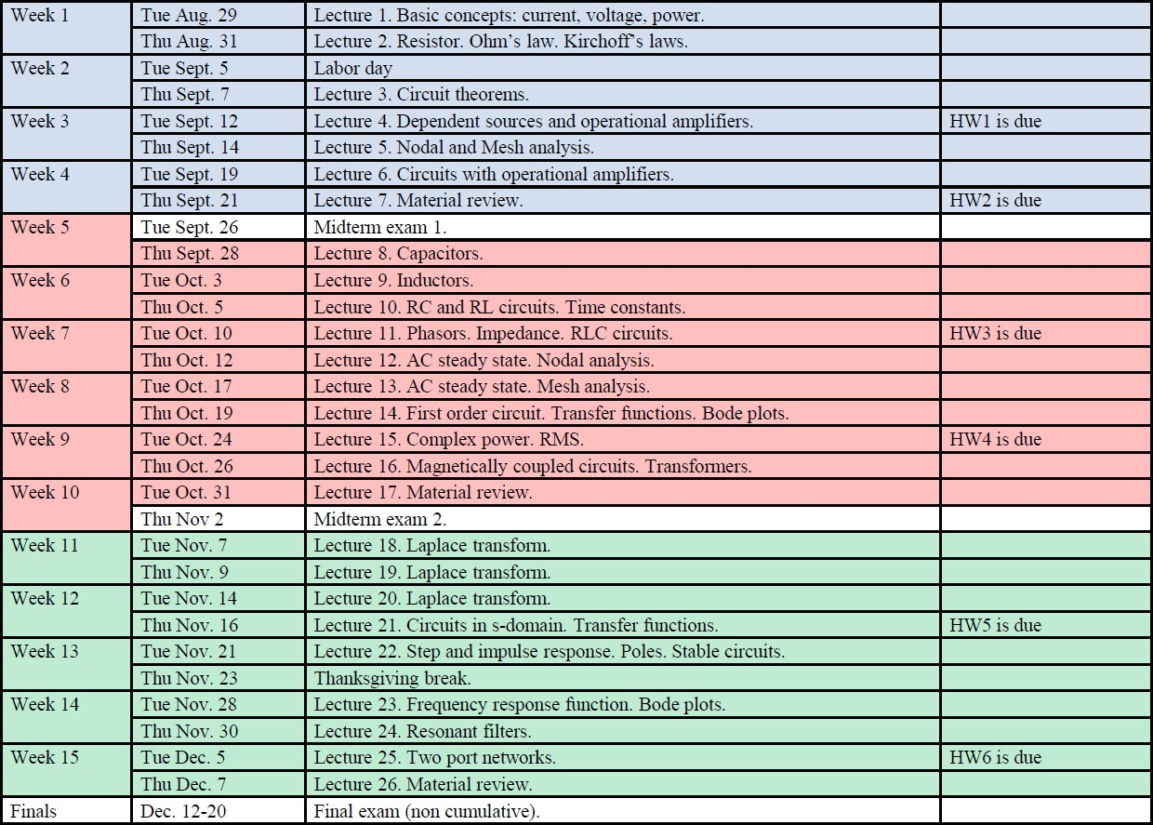
Topics Covered:
Class Schedule: 2.6 lecture hours and 1 recitation hour per week.

Student Outcomes | %  contribution*
- (a) an ability to apply knowledge of mathematics, science and engineering | 35
- (b1) an ability to design and conduct experiments | 18
- (b2) an ability to analyze and interpret data | 17
- (c) an ability to design a system, component, or process to meet desired needs within realistic constraints such as economic, environmental, social, political, ethical,
health and safety, manufacturability, and sustainability
- x (d) an ability to function on multi-disciplinary teams
- (e) an ability to identify, formulate, and solve engineering problems
- x (f) an understanding of professional and ethical responsibility
- x (g) an ability to communicate effectively
- x (h) the broad education necessary to understand the impact of engineering solutions in a global, economic, environmental, and societal context
- (i) a recognition of the need for, and an ability to engage in life-long learning
- (j) a knowledge of contemporary issues
- (k) an ability to use the techniques, skills, and modern engineering tools necessary  for engineering practice | 30
- Any other outcomes and assessments?

* Assume that the total contribution of any course will be 100%. Use the right hand column to indicate the approximate percent that the left hand columns contribute to the overall course.

Document Prepared by: Sergey Suchalkin Date: August, 2016

