SPRING
WEDNESDAYS
We've Gone Virtual!!

2021

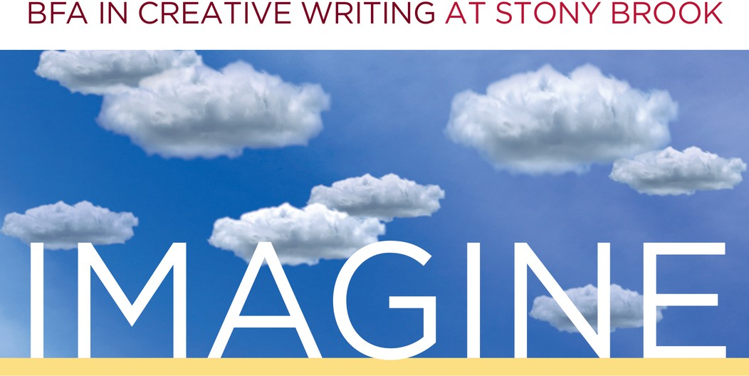

Feb.17 ~ Meet Your Professors
Molly Gaudry Julie Sheehan Miranda Beeson
Genevieve Sly Crane Emma Walton Hamilton Paul Harding
Kaylie Jones Megan McAndrew
Welcome back, Wolfie writers, and welcome, newly admitted students! Bring any questions you have about academics or life as a creative writing major or minor. RSVP Here

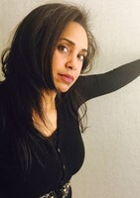
Mar. 3 ~ Poetry Reading

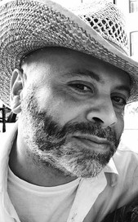
Join us for an afternoon of poetry with Pulitzer Prize winner, Tyehimba Jess, and SBU's own Michelle Whittaker. Join us live on YouTube!
Mar. 24 ~ Nonfiction Faculty Reading Featuring Stony Brook professors: Robert Lopez and Kaylie Jones. Join us live on YouTube!


Apr. 14 ~ TA Reading
Find out what your professors are writing. Join us live on YouTube!

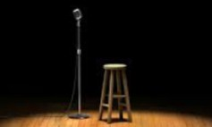
Apr. 28 ~ Student Showcase
Undergraduate writers, it's your turn to shine! Join us live on YouTube!

