SPRING

WE D N E S D A Y S
Melville N3045 1-2:20PM
2024

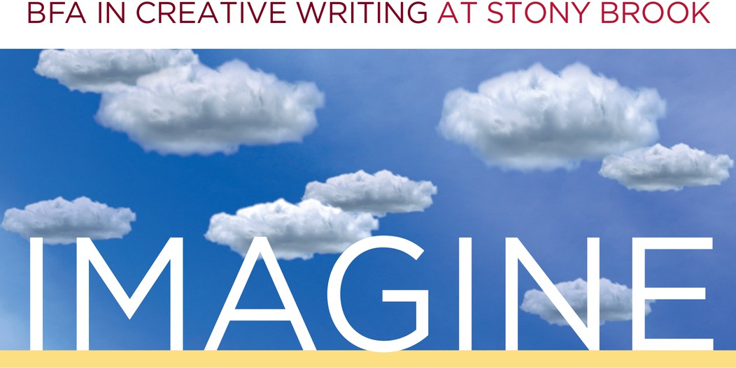

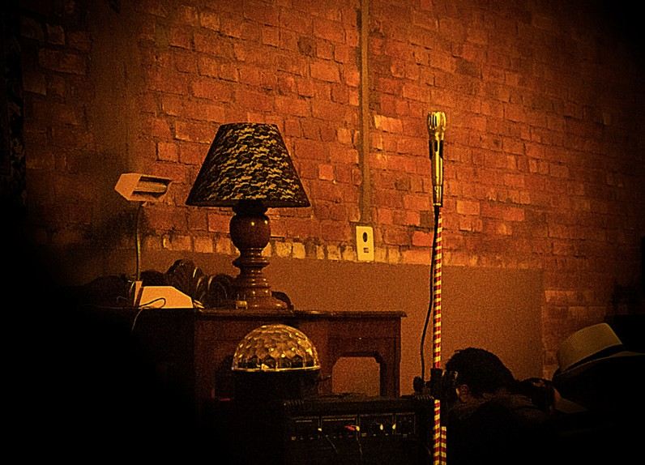
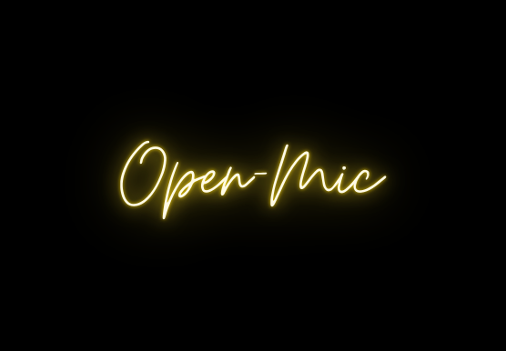


JAN. 31 ~ Award-Winning Author Paul Harding

A reading from Pulitzer-Prize-winner Paul Harding’s latest novel, This Other Eden, followed by a Q&A.

FEB. 21 ~ Open Mic Coffee House
Undergraduates, sign up to read at our open mic event. Enjoy hearing your fellow students read from their latest work. Coffee and snacks will be served.

Mar. 20 ~ Graduate Instructor Reading
Listen to your CWL 202 and 300-level instructors share what they’re working on in this multi-genre reading followed by a Q&A.

April 24 ~ Student Showcase
Undergraduate writers, it's your time to shine! Faculty-nominated writers will have the chance to share their work with their peers in a public reading.
To request accommodations or for more information, contact cwlundergrad@stonybrook.edu

