@wolfiewriters

FALL

WE D N E S D A Y S
Melville N3045 “Fishbowl” 12:30-1:45 PM
2024

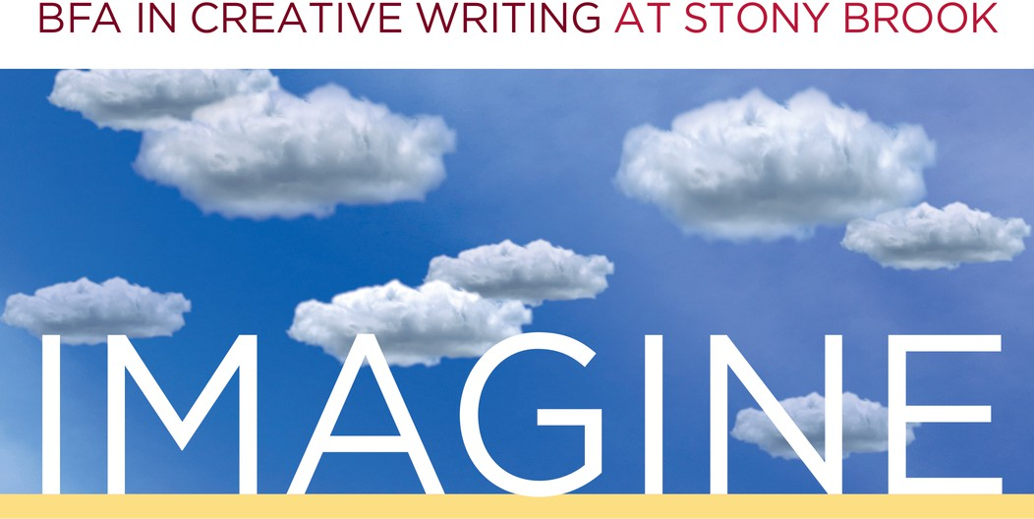

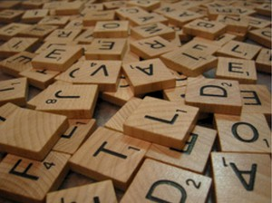
SEP. 25 ~ Welcome Mixer with word games + snacks

New and returning students gather in the Fishbowl Melville N3045 to kick off the new term and find inspiration and friendship as well as yummy snacks.
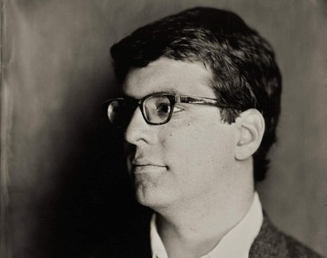
OCT. 9 ~ Faculty Reading + Q&A with Stephen Aubrey
Stephen Aubrey is a playwright, dramaturg, fiction writer, and game designer. He’s been published in CRAFT, Electric Literature, Publishing Genius, and elsewhere. He is shipping his third original tabletop role-playing game through Stillfleet Studios.
Refreshments served.
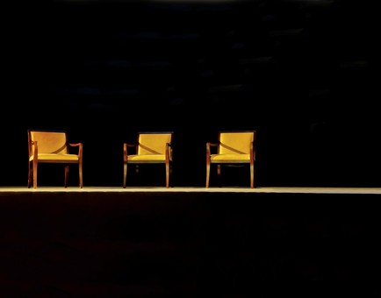
NOV. 6 ~ Alumni Panel on Life after SBU
Distinguished alumni and old friends are reunited to discuss what challenges and triumphs writers face after completion of a degree.
Lunch served.


DEC. 4 ~ Student Showcase
Undergraduate writers, it's your time to shine! Democratically nominated writers will have the chance to share their work with their peers in a public reading. Family and friends are welcome.
Refreshments served.
To request accommodations or more information, please email cwlundergrad@stonybrook.edu

