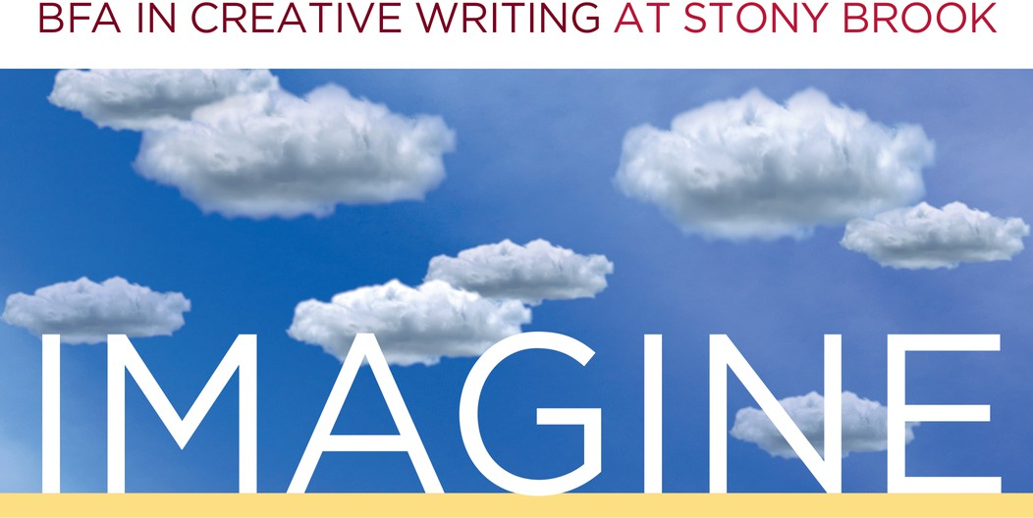
FALL
WE D N E S D A Y S
Melville N3045 1-2:20PM
2023


SEPT. 06 ~ Fall Semester Kick-Off
Welcome to a new semester, Creative Writers!
Join us for pizza, drinks, and some fun socializing with creative writing students and faculty! Bring your questions about the BFA major or minor. Hosted by LB Thompson.

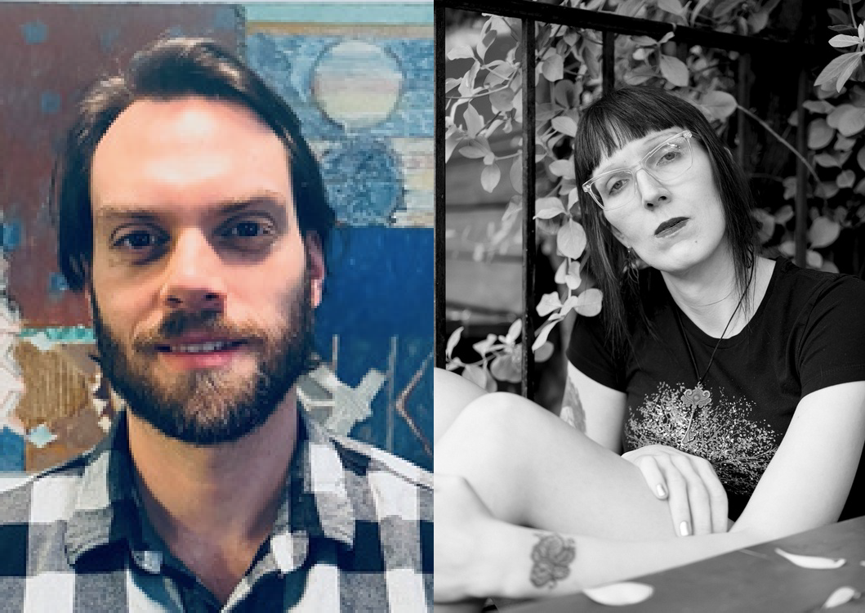
OCT. 11 ~ Writers Bobby Crace & Casey Plett
Join fiction writer Bobby Crace and novelist Casey Plett as they showcase their award-winning work with a Q&A to follow.


NOV. 08 ~ Graduate Instructor Reading
Listen to your CWL 202 and 300-level instructors share what they’re working on in this multi-genre reading followed by a Q&A.


NOV. 29 ~ Student Showcase
Undergraduate writers, it's your time to shine! Faculty-nominated writers will have the chance to share their work with their peers in a public reading.

To request accommodations or for more information, contact cwlundergrad@stonybrook.edu

