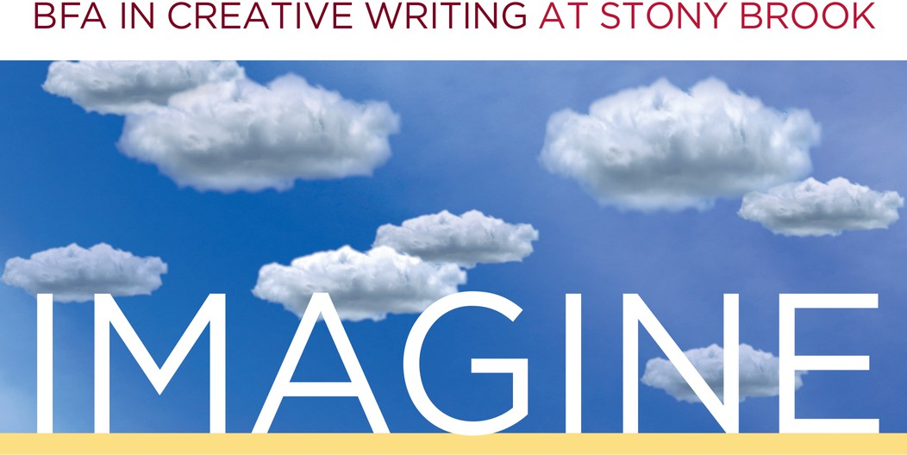
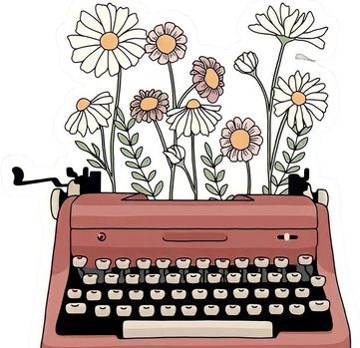
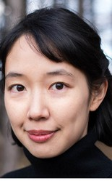
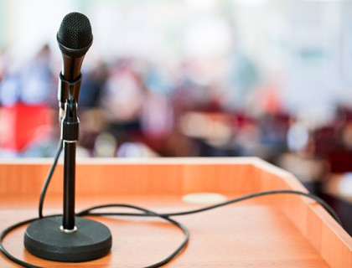
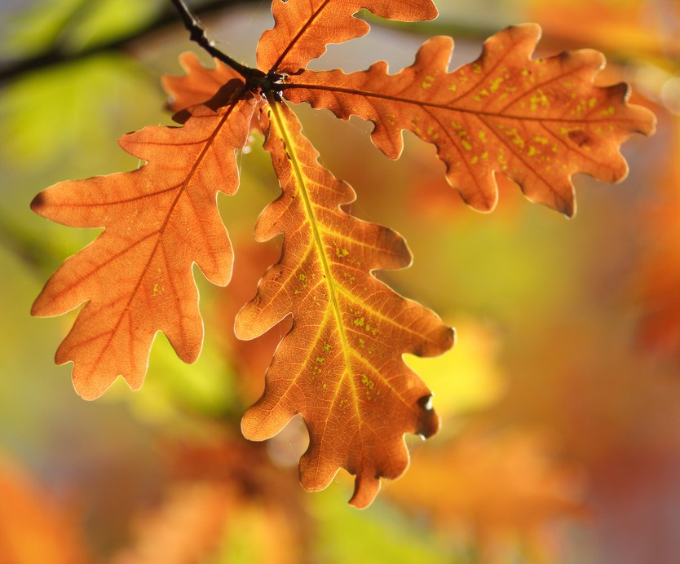
FALL
WEDNESDAYS
Melville N3045 1-2:20PM
2022

AUG. 31 ~ Fall Kick-Off: Welcome Back-Get Together!
Welcome back to a new year, Creative Writers! Please join us for snacks, drinks, and some casual socializing with creative writing students and faculty! Director Genevieve Sly Crane will be available to answer questions about the BFA major or minor.

SEPT. 28 ~ TA Reading

Find out what your CWL 202 and 300-level instructors are writing! Hosted by Scott Mackenzie.

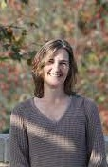
OCT. 26 ~ Faculty Reading

Join us for our annual fall semester faculty reading, featuring Julie Sheehan and new faculty member Christine Kitano!

NOV. 30 ~ Student Showcase

Undergraduate writers, it's your turn to shine! Hosted by James Yeary.

To request accommodations or for more information, contact cwlundergrad@stonybrook.edu

