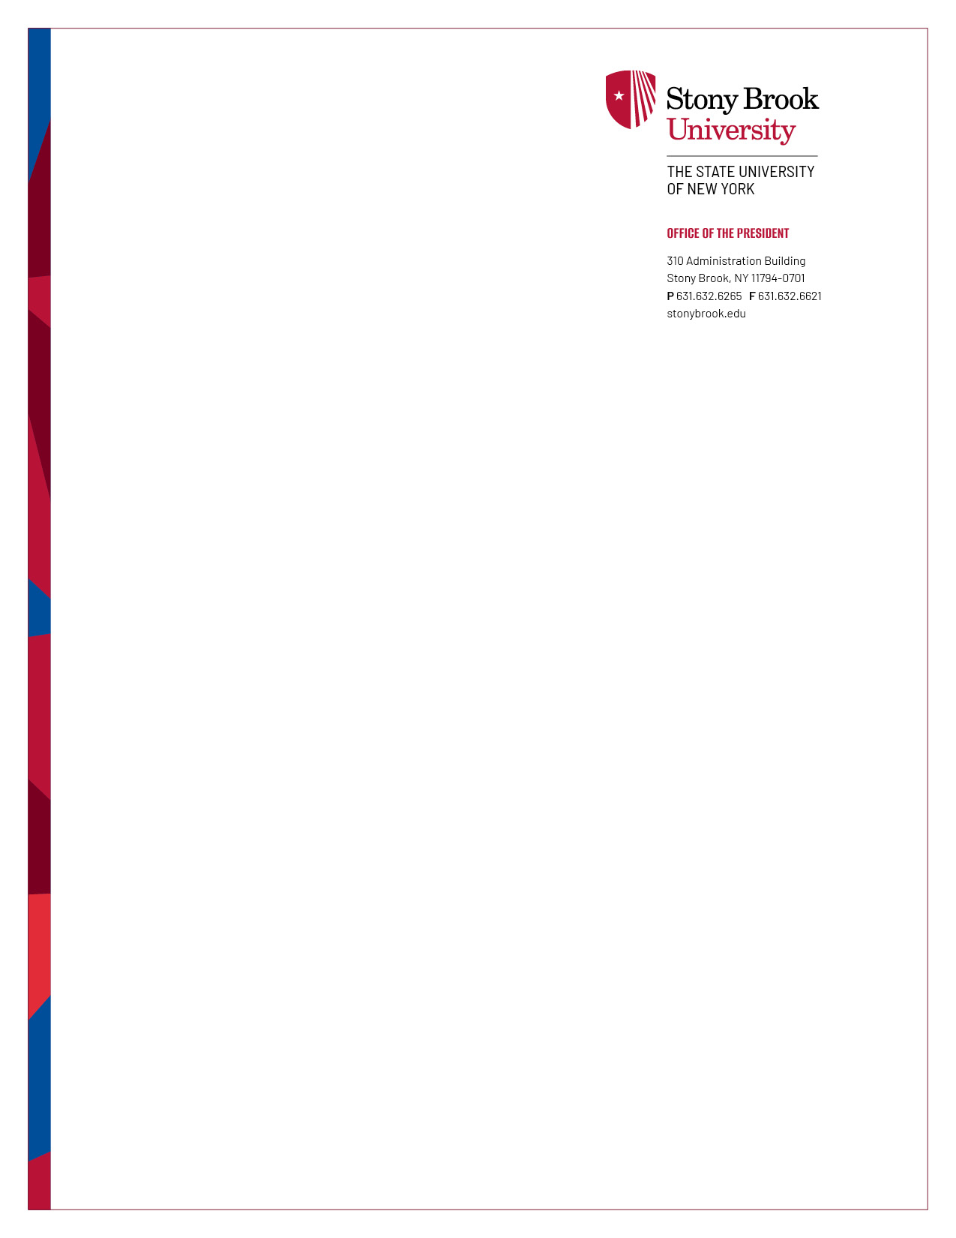
MEMORANDUM

September 18, 2025

To: Stony Book Faculty and Staff

From: Andrea Goldsmith, President

Re: Employee responsibilities regarding internal controls

The New York State Governmental Accountability, Audit, and Internal Control Act of 1987 (Internal Control Act) requires state agencies and other organizations to promote and practice good internal controls, to establish internal control programs, and to provide accountability for their activities. As president, I affirm my support for a strong and structured system of internal controls at Stony Brook University.

As a flagship of The State University of New York, we have been entrusted with significant resources from the public, students, patients, and donors to fulfill our education, research, healthcare, economic and cultural development, and diversity missions. To do so, we share a responsibility to maintain a system of internal controls to protect university resources and assets and ensure the achievement of organizational goals and objectives. An effective system of internal controls helps promote efficient operations, accountability, compliance, integrity, ethical behavior and responsible stewardship. These controls are essential in preventing loss due to fraud, waste, error, or misuse while at the same time protecting employees and preserving the university’s reputation.

For the internal control program to succeed, it is critical that members of the university community understand their respective roles to:
- identify risks within their areas of responsibility,
- establish appropriate controls to mitigate risks,
- implement and adhere to policies and procedures to address risks,
- fulfill the duties and responsibilities established in position descriptions,
- understand and comply with applicable policies, procedures, laws, and regulations,
- take all reasonable steps to safeguard university assets,
- attend training to increase understanding of internal controls,
- continuously develop skills and abilities,
- report internal control breakdowns where observed, and
- complete annual financial and conflict of interest disclosures as required.

While individuals’ roles in the internal control system vary greatly based on position, responsibility rests with personnel at every level of the organization. Internal controls are about ensuring competent individuals are taking the correct actions and collaborating to successfully achieve the organization’s goals. Should you have questions on internal control-related matters, please contact Douglas Panico, our internal control officer. Your continued contribution and cooperation are greatly appreciated. Thank you for all you do for Stony Brook.

